***** Press release *****
New basic autopilot by Jefa Rudder & Steering systems
Yachting autopilots have been around for many years and several companies are involved in producing electronic autopilots for sailing yachts. In all the years of development, yachting autopilots became more and more complex and expensive and no basic solution was available any more.
Jefa Rudder & Steering, world’s biggest manufacturer of rudder- and mechanical steering systems, is known for its unique autopilot drive units which interface with all existing autopilot manufacturers. The lack of a basic autopilot triggered the Jefa R&D department and the result is the new JEFA autopilot AP-1.
The Jefa AP-1 autopilot is the answer to the request from the market for an affordable and easy to operate standalone autopilot. The development has been inspired by many years of experience in the successful production of Jefa autopilot drive units. Special attention was given to an intuitive and user friendly control panel which is 100% water tight. The three dimensional integral compass (also used in high end defence missiles) ensures an extremely steady course also at high seas. The Jefa AP-1 autopilot is suitable for tiller as well as wheel steered boats using a variety of under deck JEFA autopilot drive units. All drive units can have an integral rudder feedback unit, so no separate installation is necessary. The Jefa AP-1 autopilot is suitable for boats up to 45 foot.
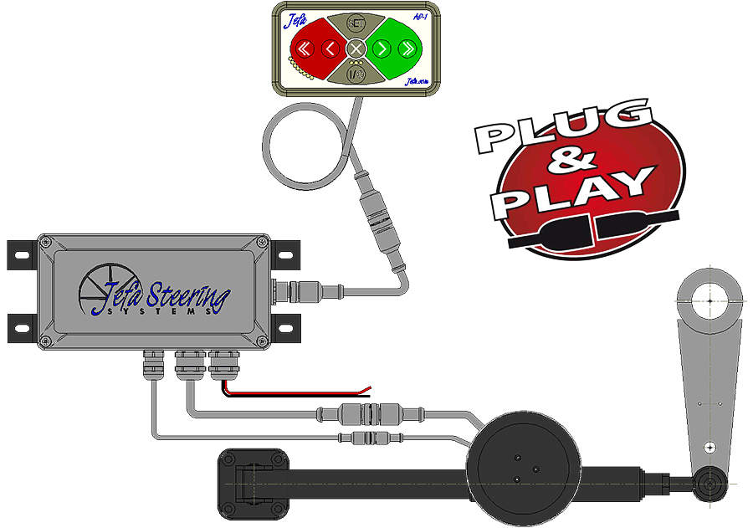
The above layout shows the super easy "plug & play" installation of the autopilot drive system. Only the plus and minus have to be connected and the drive unit, servo box and control panel are all plugged in. There is no need for a separate fluxgate compass and separate rudder feedback unit like other systems use.
The Jefa AP-1 autopilot cost € 900,- excl. VAT and in combination with a linear drive unit the price is € 1.950,- excl. VAT.
Product info is available on our website www.jefa.com and via this direct link: www.jefa.com/autopilot-f.htm
Press images are available on our FTP server at following link ftp://ftp.jefa.com/steering/press/AP1_autopilot/

For more information, please contact Armin Geisler at armin@jefa.com
Armin Geisler
Sales Director Jefa Rudder & Steering
International Jefa Sales Office Holland
Tel: +31 475 537760
Fax: +31 475 537759
e-mail: armin@jefa.com
Skype Name: armin_geisler_work

